Jira Assignment 7

Screenshot # 1 – Burndown Chart

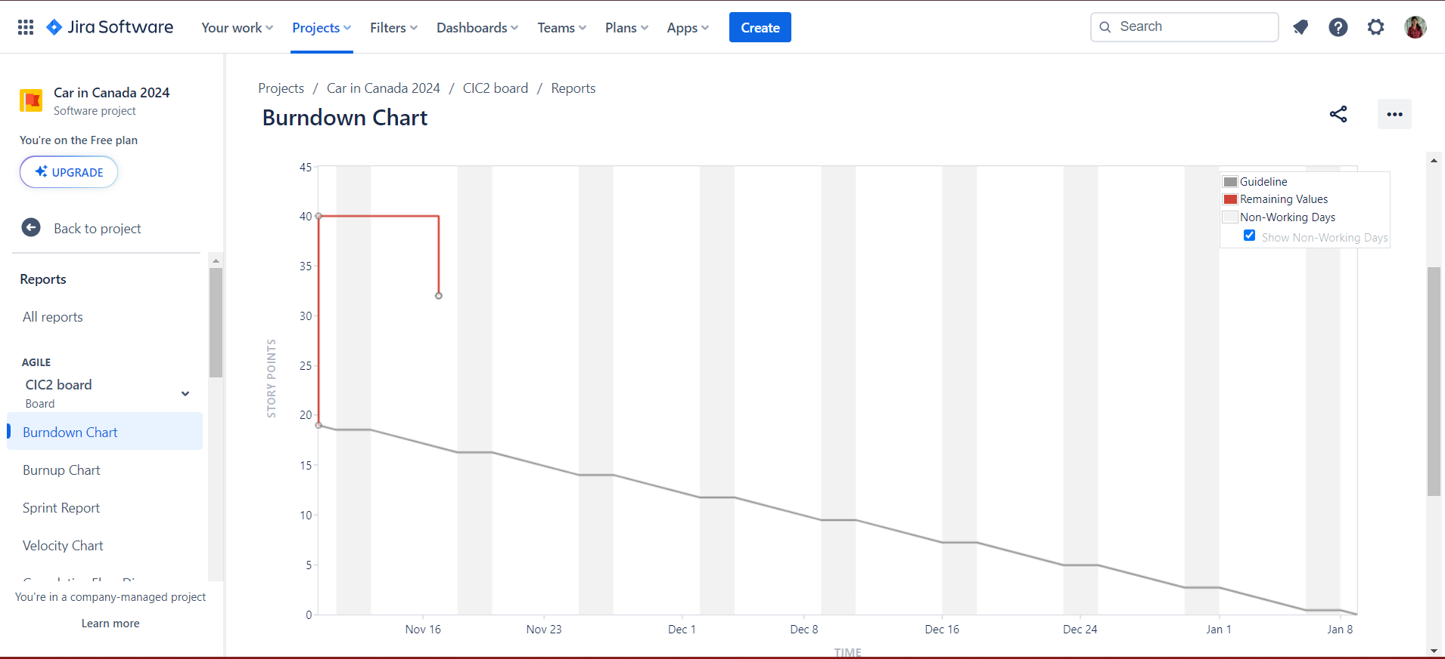

Screenshot # 2 – Burnup Chart

